Matthew Rushton
m.rushton1103@edmail.edcc.edu

Rushton Guitars Website
All Things Guitar – Talent Not Included

Purpose And Description
The purpose of the Rushton Guitars website is to showcase guitars made by other manufacturers and also custom guitars made by Shayne Rushton with the intention of making profits through sales. The website allows you to choose featured products or customize your own guitar. You can purchase as many of each as you wish.

Website Demonstration
The live version is available online via github.com. The url is https://www.mshaynerush.github.io/rushtonguitars

Home page
The home page shows featured brands. From here you can navigate to the catalog or custom shop page.
Navigation
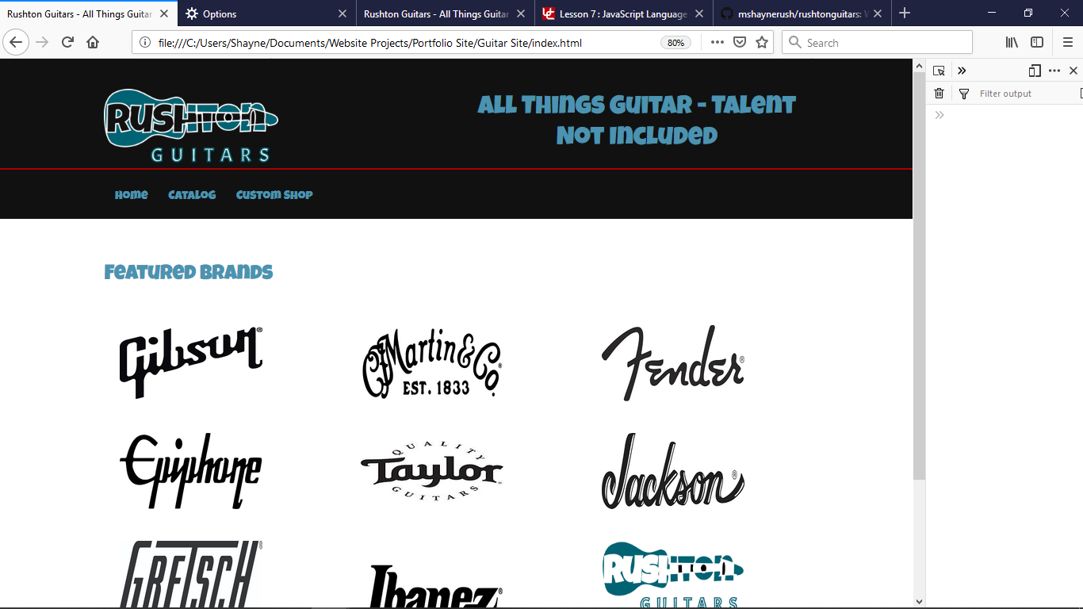

Catalog Page
All featured guitars are available here. As you add guitars, they are placed in your cart.
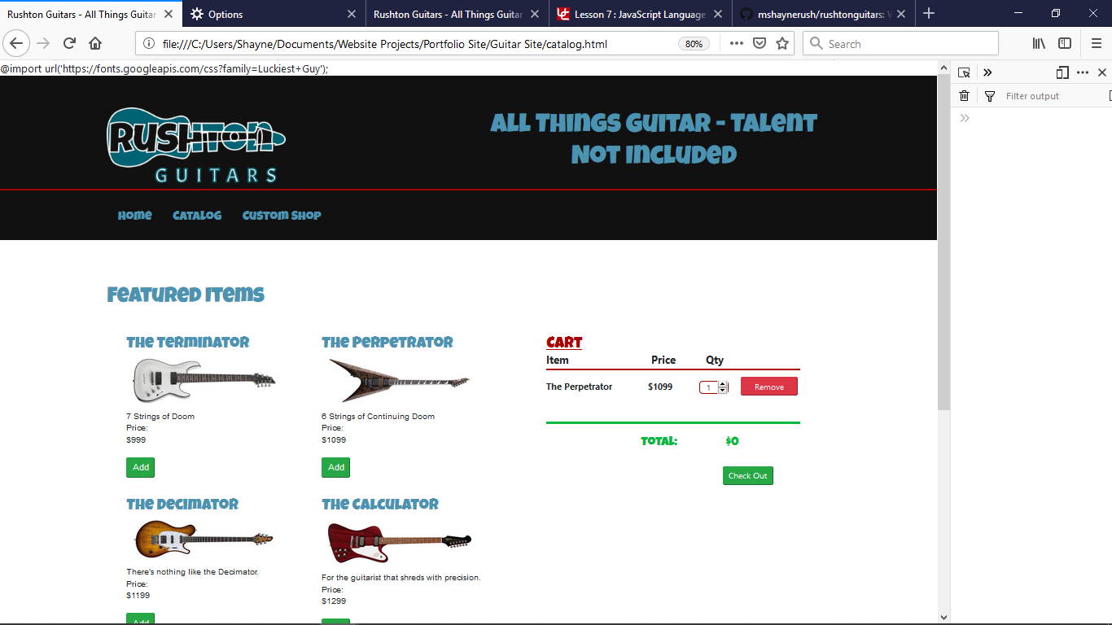
Click the Green Add button to add the guitar. Guitar is Added to Cart

Custom Page
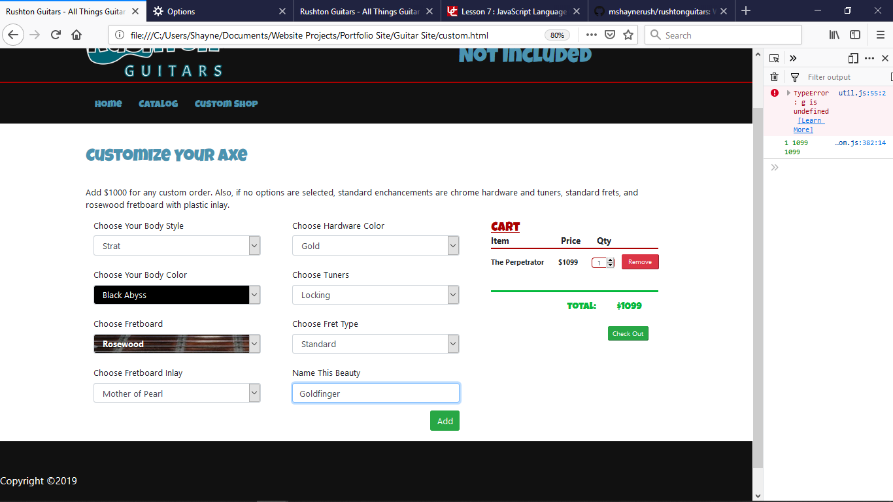
Select options for your custom guitar, including body style, color, fretboard type, frets, hardware color and tuners. You can even give it your own name.

Options change based on colors chosen:

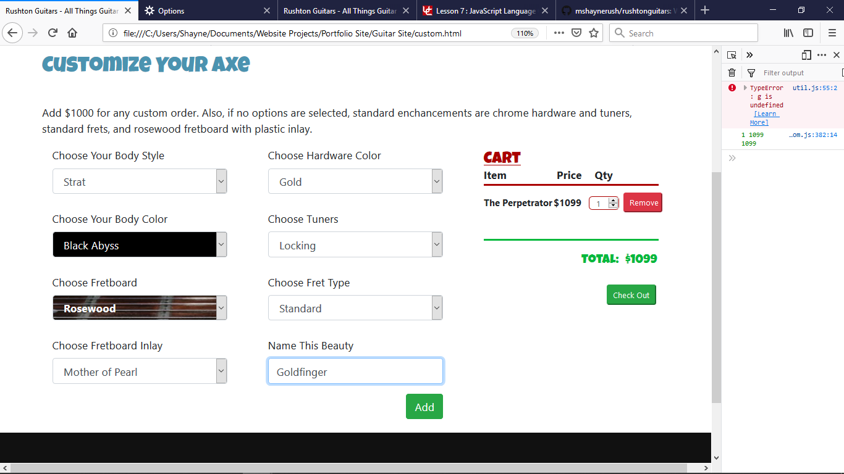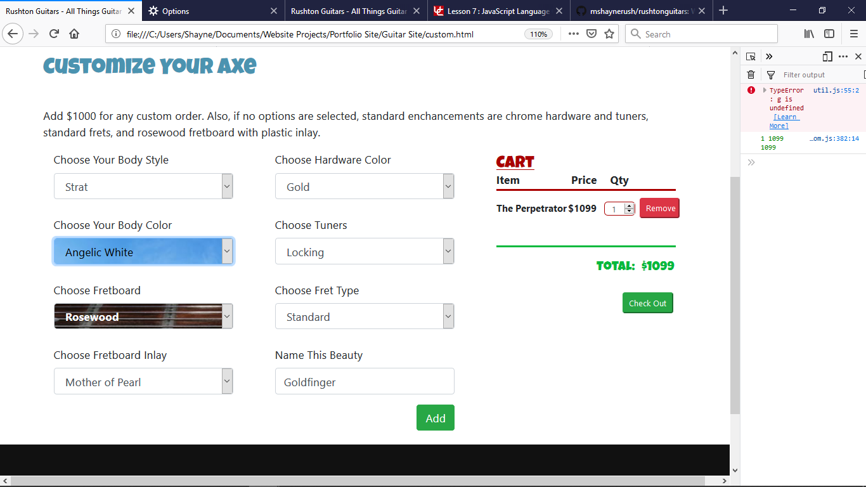

Cart Section
The cart section is updated any time you add a guitar, remove one or change the quantity. Quantities can never go below zero. The cart will update the total as you go.

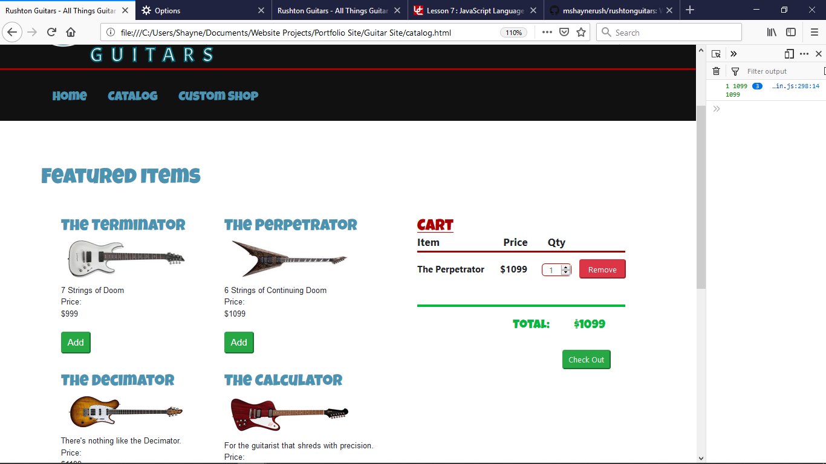

Checkout Page
Enter your information. All fields are required except the unit number and phone number. But if you enter the phone number, it will force the format XXX-XXX-XXXX. The email responds accordingly also.
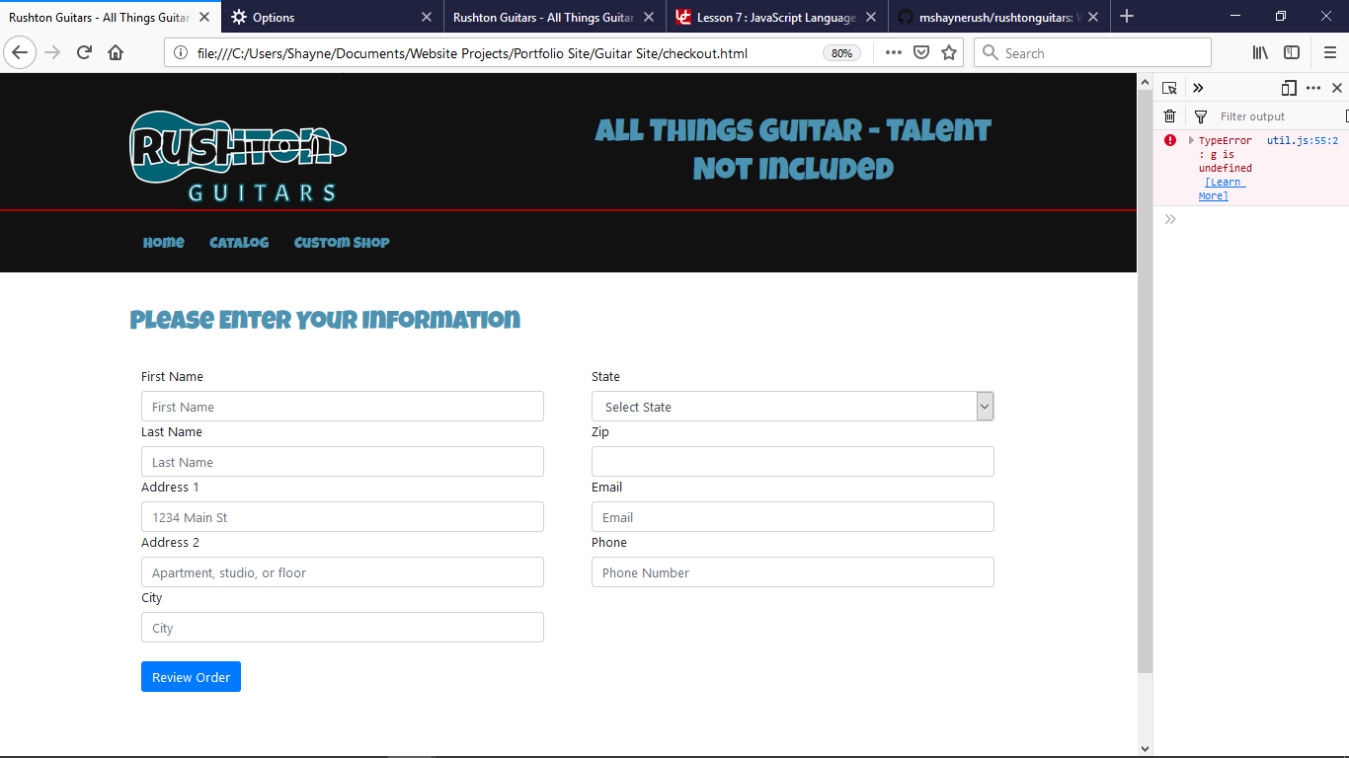

Order Review Page
Your information will show here as well as your cart information. Click the green confirm button and you will be taken to the thank you page. The cookie will then be cleared of cart items, but will not clear your data. If you go back and shop, the checkout page will be bypassed so you do not have to re enter your information
Your order
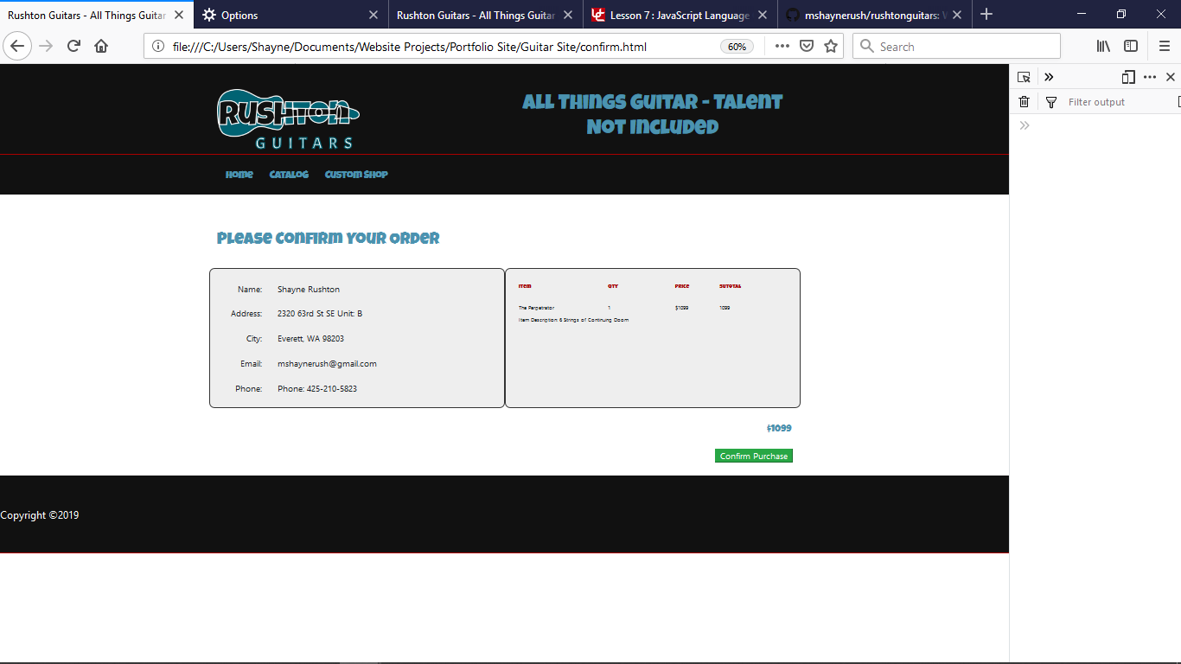
Responsive Design
Rushton Guitars is built with mobile device users in mind.

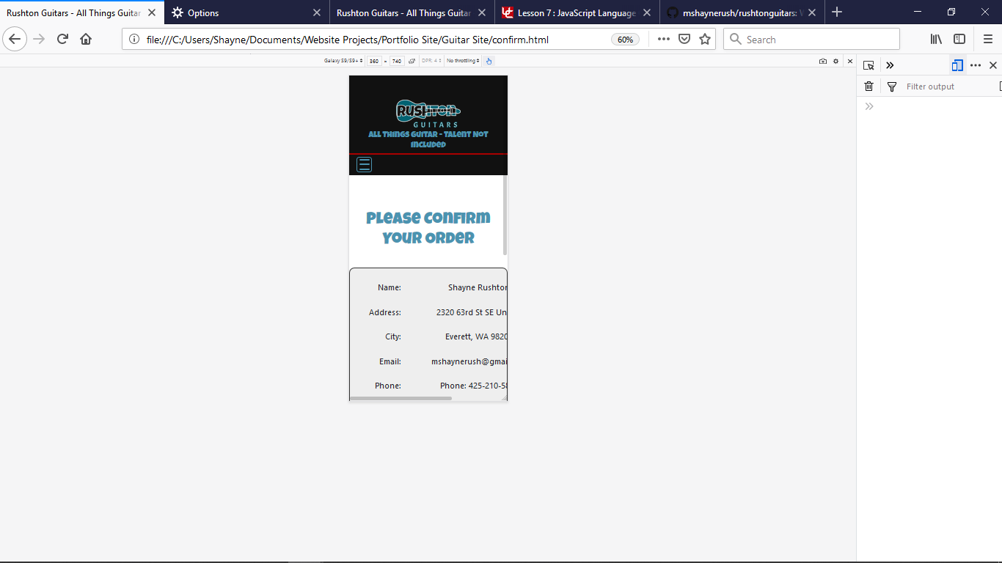
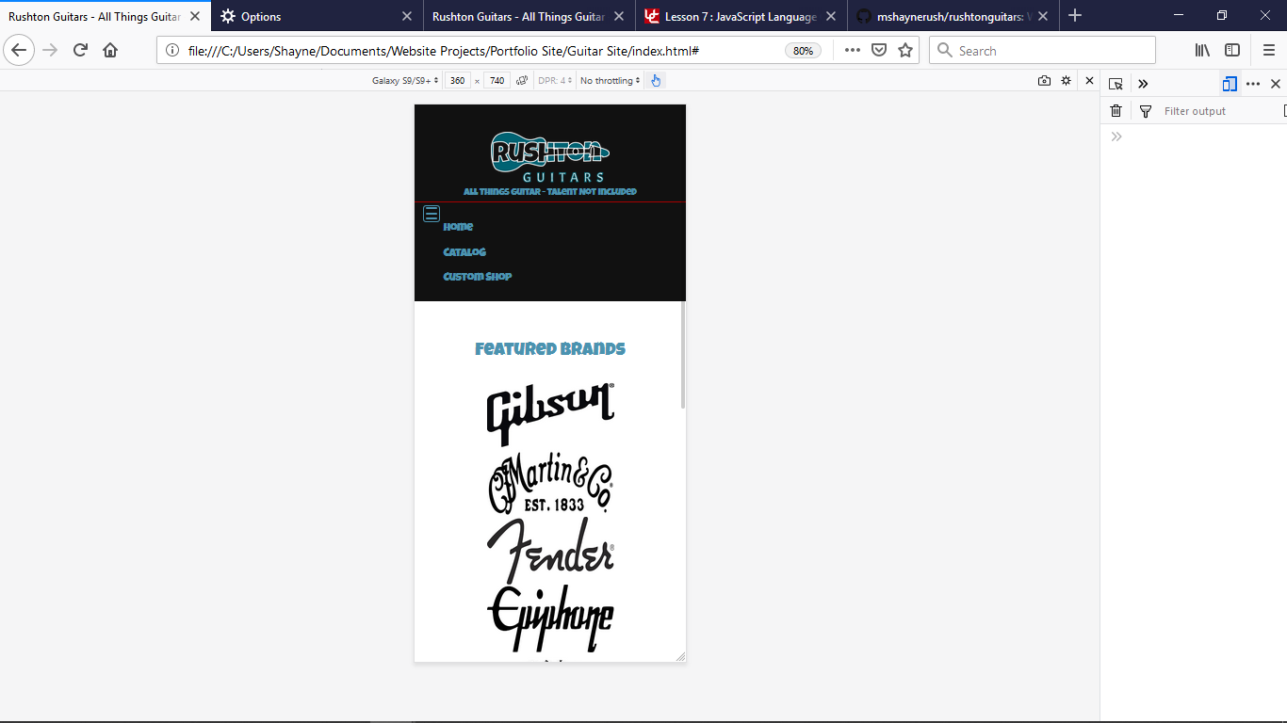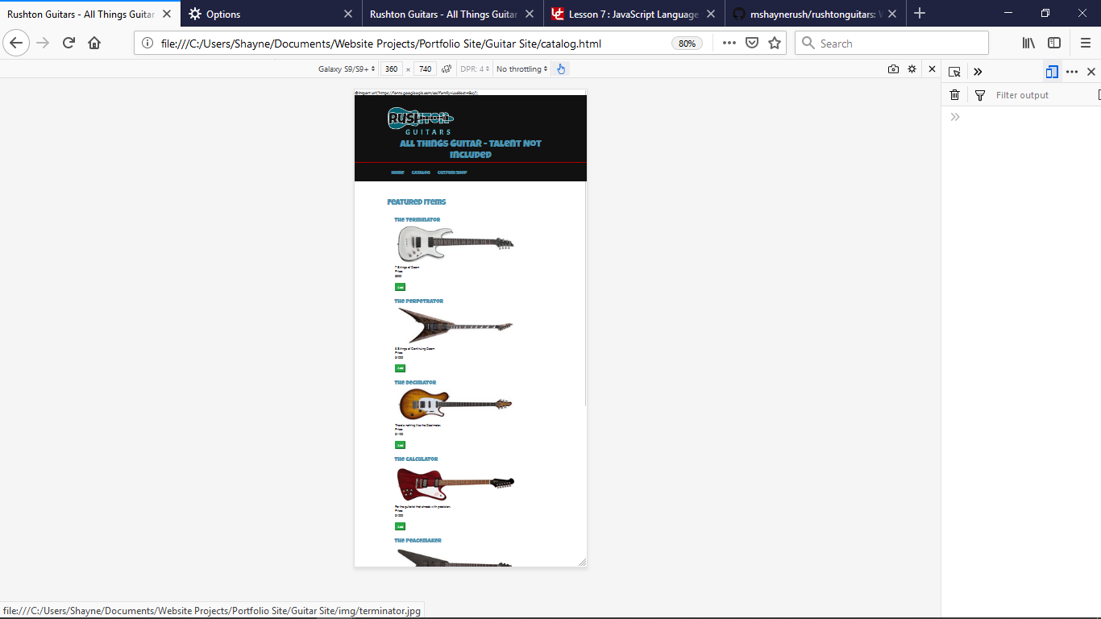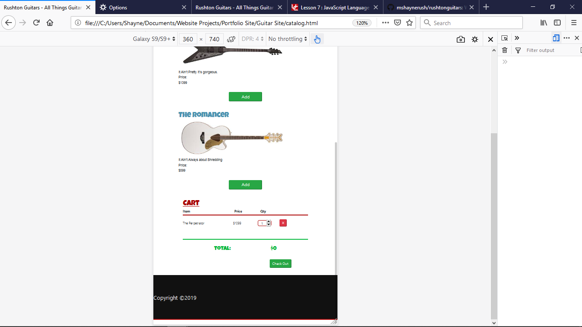
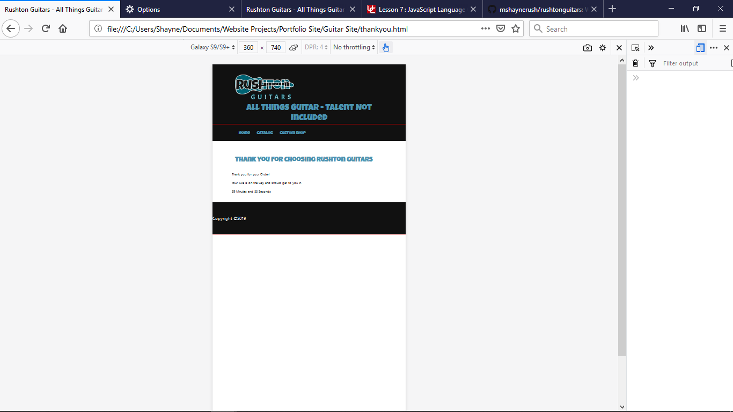
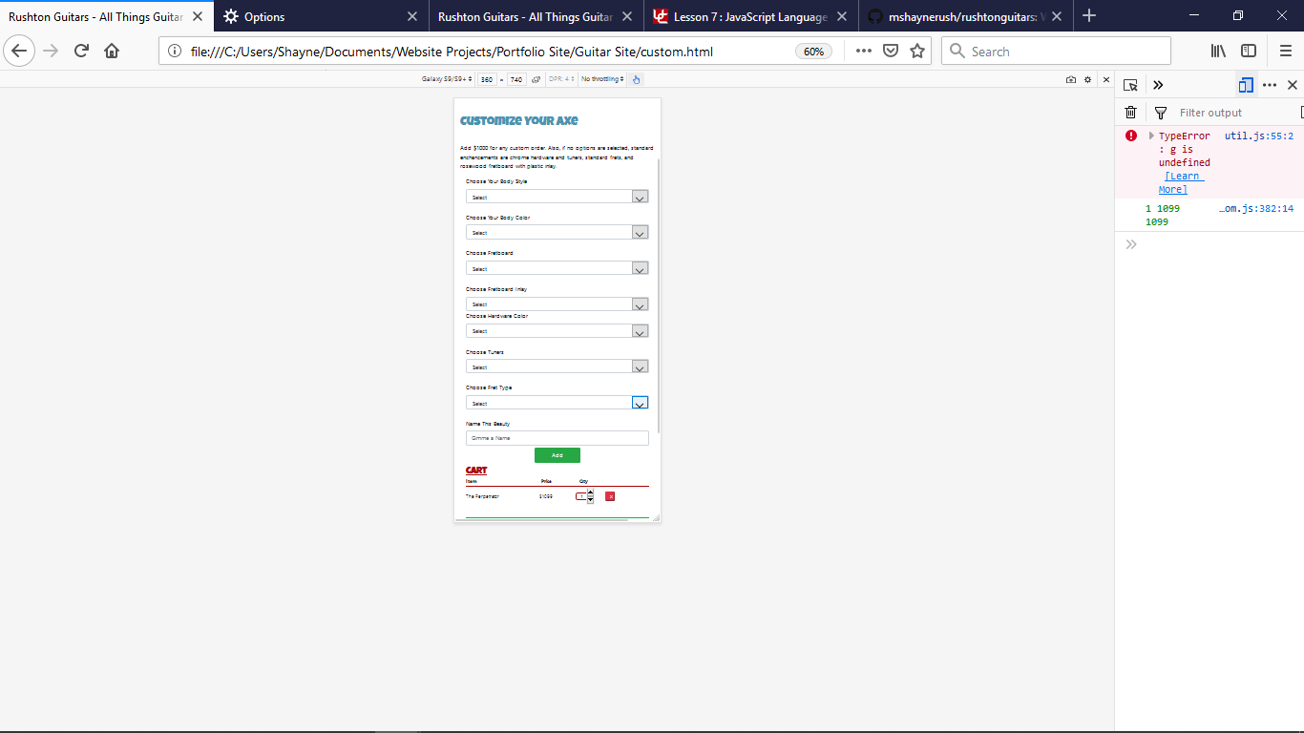

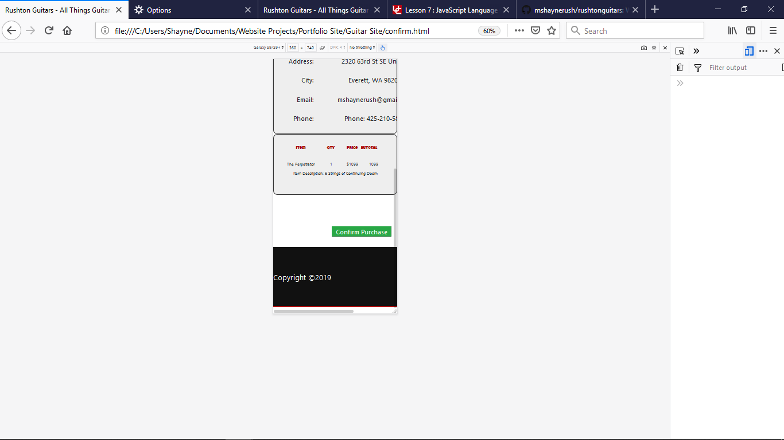

Thank You Page
Once the order Is submitted, the last page will give a timer countdown for when your guitar will arrive

